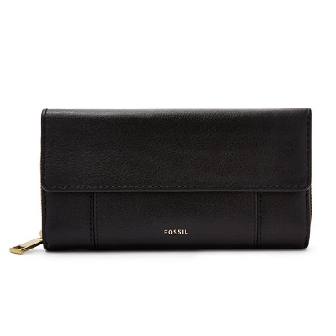

Jori RFID Flap Clutch

PRODUCT DETAILS

**Silhouette: Flap Clutch**

**Exterior Material: Leather**

**Interior Details: 2 Bill Compartments, 14 Credit Card Slots, 1 ID Window**

**Measurements: 7.8"L x 1.6"W x 4.2"H**

**Warranty: 1 Year Limited**